***Hispanic/Latino Community - Focus Groups Results***

Two focus groups were conducted with Latino residents, one through SeaMar Community Health Center and the other through the South Park Information and Assistance Resource Center (SPIARC). This was part of the *Information Technology Access and Adoption in Seattle: Progress towards digital opportunity and equity* study conducted by the City of Seattle. Both groups were recruited from the staff, clients, volunteers, and friends of their organizations. The group hosted by SeaMar was held at the South Park Neighborhood Center on June 18, 2013, and the group hosted by SPIARC was held at the South Park Community Center on June 26, 2013. Twenty individuals attended the SeaMar focus group and twenty-three attended the SPIARC group. Each group also included four bilingual note-takers/ table facilitators, and a bilingual group facilitator. Participants from both groups took a brief written survey. Participants engaged in planned focus group activities – a dynamic method that relies on *mutual interviewing* among the community members – and did so with evident interest and engagement.

**Table 1. Group demographic description**

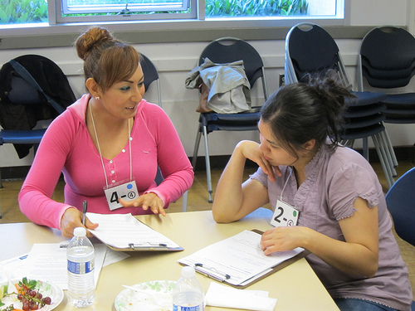Table 1 summarizes the demographic distribution of the two groups. Both groups indicated substantial diversity of educational achievement. About a quarter of each group has not completed high school, and about one-third of each group has had at least some college. Analysis of group demographics showed that they are similar except that the SeaMar participants are far more likely to say they are unemployed (26% vs. 0%), while the SPIARC group is considerably younger, (80% are 35 or younger, compared with only one-third of the SeaMar group) and somewhat more likely to be students (43% vs. 21%).

|  |  |  |
| --- | --- | --- |
|  | SeaMar | SPIARC |
| % women | 80% | 60% |
| Education |  |  |
| Less than high school | 25% | 26% |
| HS grad/GED | 40% | 42% |
| Some college/AA/AS | 15% | 5% |
| BA/BS | 15% | 26% |
| Post grad work/degree | 5% | 0% |
| Age |  |  |
| 18-25 | 22% | 35% |
| 26-35 | 11% | 45% |
| 36-50 | 28% | 15% |
| 51-64 | 28% | 5% |
| 65 or older | 11% | 0% |
| Employment |  |  |
| Employed | 37% | 57% |
| Homemaker | 21% | 24% |
| Student | 21% | 43% |
| Disabled | 5% | 0% |
| Unemployed | 26% | 0% |
| Income |  |  |
| <$20,000 | 53% | 77% |
| $20K-$30K | 7% | 12% |
| $30K-$40K | 33% | 12% |
| $40K-$50K |  |  |
| $50K-$75K |  |  |
| $75K-$100K | 7% | 0% |
|  |  |  |
|  |  |  |

**Summary**

Latino participants in both groups value access to the Internet, though many are seeking a way to improve their skills: almost a quarter said they had no or few computer skills and another one-third rated their skill level just one step higher - still below the midpoint. Though many have computers at home, only about half have Internet access on their home computers or laptops, with some explaining that it's because Internet access is too expensive. Two-thirds of these participants access the Internet on a mobile device. Without a data plan, many participants with mobile devices said they use a wi-fi signal from a community library. E-mail is the primary way participants who do not have telephone access communicate. Some of these residents have a smart phone that they use to send and receive email, but not as a telephone. Public access computers at the library or other locations are also very important for these respondents, who report that the short time limit on busy public computers makes it difficult for them to improve their skills.

While many participants in the Latino groups have developed strategies to access the Internet, even if the service is unaffordable or unavailable, others report having little or no access and a low level of computer skills. Some of those with "borrowed" access would like more or at least more convenient access. Participants were especially interested in Internet access for health-related information, to enable communication with others, and to study. Interviewer comments went further, clarifying that participants value both the breadth of information they are now able to access, and the great speed with which they can find it.

Similar to responses in other groups, participants expressed the most satisfaction with their Internet reliability and customer service, less satisfaction with the speed, and are least satisfied with the cost. Despite this, participants are willing to pay a little more per month for faster access. They also expressed great interest in the potential of high speed Internet, even while many articulated concerns about the privacy and security of personal information, the potential cost of the service, and the cost and complexity of upgrading equipment.

These groups distinguished themselves from other focus groups in this study in their particularly high level of social media use: 87% said they use social media, mostly Facebook. Two-thirds say they check Facebook daily and only 14% don't use it at all, a pattern similar to email use. The few who don't use social media and don't want to expressed concern about their privacy. Participants were largely positive about the idea of using social media to communicate with government because, assuming that material would be available in Spanish, they would be able to get ready access to important information and to services, but here, too, some expressed concern about privacy and security of confidential information, remarking that "everyone would know," and some opined that social media isn't a good form of communication because the government won’t answer. One person worried about the negative opinions that are attracted to social media.

While participants were positive about giving opinions to government by electronic means, they also very clearly value personal contact, calling for more community meetings similar to the focus group. They are also open to *getting* information *from* government by electronic means, but also value TV news and notices in the mail. Interestingly, despite their willingness to give opinions and get information by electronic means, participants asked for *printed* material (newsletter, flyers) or *interpersonal* interactions (community meetings) when it comes to receiving information that would help them improve their community.

The great majority of focus group participants would like to learn more about using computers and the Internet, most often by taking classes or short workshops.

**Technology Access and Use**

*Survey* responses show that about 79% of respondents have a cell phone - 41% of them are smart phones. Two-thirds of the respondents use texting. Only 30% also reported having a landline, consistent with other groups in this study.

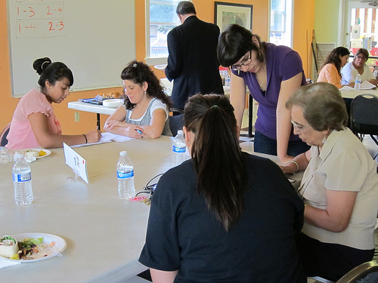Nearly all (93%) of the participants use computers and/or the Internet, *about two-thirds on a mobile device (cell phone or tablet)*. Interviewing revealed that at SPIARC, this figure was 86% and at SeaMar, 53%. The SPIARC facilitator mentioned that many of the women at SPIARC do not have telephone access and so must rely on email for communication. She commented that people sit in their cars at the library using the library's Internet signal on a mobile device - without having to pay for home Internet access, a data plan, or perhaps even for telephone service. Interviewees noted that 80% of participants have a computer at home and 83% noted in the survey that they have Internet access at home or that they get their Internet access via a data plan for a cell phone or tablet. Only about half of the participants have home Internet access via a computer (32% cable; 15% DSL; 3% Satellite); another 28% is by data plan.

Both groups noted the need for lower cost or free Internet access. Some pointed out that the high costs were especially hard to accept, given the slow speeds. The SeaMar group (the group more likely to be unemployed) asked for more information about the $10.00 low income Internet program currently offered by Comcast, CenturyLink and some Clear wireless providers. Participants in this group also expressed a need to learn basic software programs (like Microsoft Office).

Nearly all of those who don't have home computers or Internet cite financial reasons, not resistance, and a few mentioned that they don't have a signal or that they don't know how to use a computer.

Respondents were given a list of possible ways they might use computers and the Internet. This group checked an average of four different uses, illustrated in Figure 1. The groups did not differ significantly on their responses to any of the choices. Nevertheless, unless the rates of use were within a few percentage points, both groups' results are presented in the figures as well as the total to provide each agency with a clearer understanding of their group.

The most frequent use is to search the Internet, particularly for health information, followed by watching TV. SeaMar participants were especially interested in getting health related information and even suggested using social media to keep the community informed about health topics.

**Like about using computers and the Internet**

* I can look for a lot of information that is very necessary for work and school
* all the information readily available
* I can have any type of info and stay connected to the world
* I can access anything I want as well as information or connect with my friends
* online - quick and easy access to information, online bill pay, online training, shopping, programs, music

**Those who do not use the Internet now want to...**

* communicate with others, to get informed on health topics, news.
* pay bills; look up directions; to learn English.

*Interviewers* asked interviewees what they like most about using computers and the Internet. Participants frequently mentioned being able to communicate with others and stay connected, and almost as often, being able to study or get information. About a quarter of the participants wanted to keep up with news and community events and a few mentioned entertainment. Although the theme of convenience was not explicitly mentioned, it seemed to be a common denominator in many of the notes, as well as the notion that a wide variety of information that had not been accessible previously, was not only available thanks to the Internet, it was available quickly.

Figure 2 shows that the great majority of participants access the Internet from home and that a large number in both groups also access computers and the Internet from other locations aside from school or work (half of the SeaMar group and 71% of the SPIARC group). Public access is important to numerous participants in both groups. The library is visited by more of the SPIARC group (50%), followed by friends' and relatives' (one-third), and that pattern is reversed for the SeaMar group (33% go to friends' and relatives' and 22% go to the library). In the *mutual interviewing* results as well, public computers and Internet access is highlighted: two-thirds report using computers at a community center, a library, a computer lab or at a friend's or relative's house.

**Using computers away from home**

* I need more time to use the Internet.
* Increase the number of computers to avoid limiting the time they can be used, facing limited time in the public libraries
* Would like Internet pricing to be more accessible and quick. (Interpreted to mean lower cost and faster speed.)
* Practice a bit more. I would need more time to improve.
* Free access to internet throughout the City without having to spend money in coffee .

When asked in *mutual interviewing* about their experience using the computers away from home, most described the experience as positive and a few described negative aspects that have also been reported in other focus groups (time limit at libraries, less privacy at friends'). About two-thirds agree that the Internet access available to them is enough for their needs. When asked what would make their experience better, people want more access - fewer limits on the public access computers, or even better, a way to have Internet access at home. Some people mentioned wanting the training and experience to advance their computer skills and one person pointed out that to achieve this goal, she needs more time at the computer.

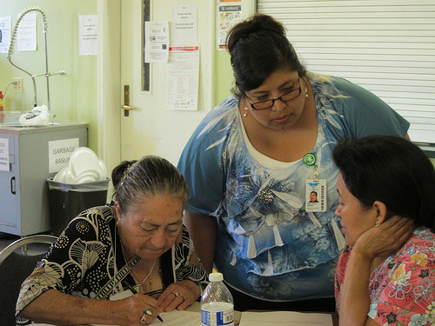When asked about their satisfaction with different aspects of their home Internet service, most survey respondents were satisfied with the reliability (80%), speed (63%), and customer service (74%) associated with their Internet service, but only about half (48%) were satisfied with the cost. Correspondingly, they most frequently reported that a lower price would improve their Internet service (82%), followed by speed (68%), and reliability (47%). As has been evident across our data sources in this research, relatively few people were concerned about customer service (33%). *Mutual interviewing* confirms that most participants (79%) say that their home Internet is good enough for them, with a few asking for faster access. One person would like to have access to a technician who could help with viruses. They were asked on the survey how much they would pay for Internet service or, if they already had Internet, how much they would pay for faster service, which was the case for most of these focus group participants. Eighty-eight (88%) were willing to pay something. For some, this is very little more (3% said less than $5), for others (27%) between $5 and $10; for another 35% between $10 and $20. Some were willing to pay $20 per month or more (12% between $20 and $30; 12% more than $30 per month).

**Problems using computers or Internet**

* It is still a little hard for me to get into the system because I don't know how it works.
* Her son uses Internet on his phone; she doesn't know how and has no computer.
* She does not believe she is competent enough to handle the machine.
* I'm taking classes to improve.

When asked how skilled they are with computers, about a quarter (28%) overall rated themselves as "skilled" or "expert." Most often (55%) respondents rated themselves below the scale's midpoint "None or not very" (23%) and "Know what I need to know" (33%). Overall, only about half of the respondents use email attachments. The ratings of the SeaMar group was more extreme with 32% giving themselves the lowest skill rating and 11% giving themselves the highest, compared with the SPIARC group where 14% gave themselves the lowest rating and 5%, the highest. About one-third told their interviewer that they do have some problems using computers or the Internet, such as needing more basic skills - including getting access and just getting started.

Figure 3 shows that *cost* was the top reason identified by SPIARC participants to explain why they or others in their community may not use computers or the Internet. Almost all of the SPIARC participants and more than one-third of the SeaMar participants selected cost of Internet and fewer selected cost of the computer itself. SeaMar participants were more likely than SPIARC participants to say that those without access just don't know about it.

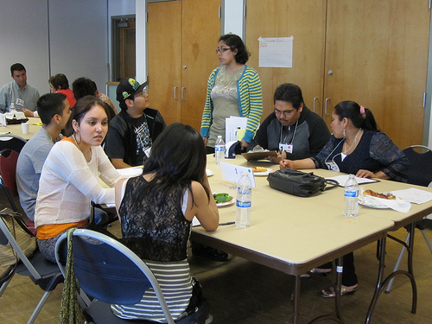

**High Speed Internet**

These sessions included the opportunity for the City to talk about the potential and possible availability of super high speed Internet in Seattle, and some of the participants discussed the pros and cons in detail.

Nearly all (95%) of the participants in these groups were positive about trying this service *and* 53% voiced a concern, including privacy, security of their personal information, and fraud (24%), the cost of the service, and for some, the potential cost of upgraded equipment (21%), the need to still have personal contact sometimes, and that services would be available in Spanish. Some participants asked for more information about the differences between current broadband access and proposed high speed access. In addition to the applications identified in the question (attending medical appointment; taking an interactive class; monitoring home; and working in groups from home), participants suggested other applications, including paying bills (18%), accessing public services and discounts available for these services (12%), and fewer than 10% named each of these: shopping; online banking; holographic whole-body video calls; homework help; and help repairing computers and protecting them from viruses.

**Using high speed Internet**

* They would like to access all the services/options presented in this question; however, the lack of knowledge about the use of internet prevents them from utilizing them.

**Cable TV and Video Content**

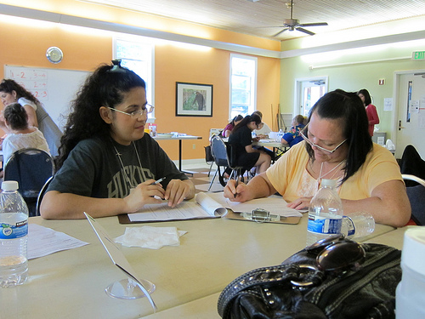Forty-two percent of these participants subscribe to cable TV. Most (74%) are satisfied with its reliability, 65% are satisfied with customer service, and only one-third are satisfied with the cost. When asked what one thing would most improve their cable service, nearly all (92%) of the survey respondents checked price. In addition, one-third each checked customer service and reliability.

Respondents were asked to rank a number of choices for getting their video content.

* Cable was the first choice for 56% of the respondents, and the second or third choice for another 12%.
* Internet programs such as Netflix and Hulu were the top choice for 39% of the respondents and a later choice for another 14%.
* Free TV was the top choice for 17% and a later choice for another 17%.
* Satellite was the top choice for 22% and a later choice for another 6%.

**Seattle.gov and The Seattle Channel**

About half of the participants overall have visited Seattle.gov, three-fourths of the SPIARC participants and about a quarter of the SeaMar participants. Just under one- third (29%) have seen the Seattle Channel, again, more of the SPIARC participants (44%) than the SeaMar participants (22%). Nearly all of those who have seen it have watched it on cable (90%) or on both cable and the Internet (10%).

When asked in mutual interviews what content or services they’d like the City to provide via Internet or cable tv, half of the participants asked for more of the type of information they need, including information about resources (43%) or information about the City, street closures, road construction or improvements, the government operations such as changes in laws, rates, or public services, and information and events about their own community (32%). About one in five pointed out that they would need Internet access to be able to access these information resources and as many asked that these resources be made available in Spanish. Some wanted these resources to be more interesting, easier to use, and possibly, more like a social networking site.

**Like and dislike about social media**

**Like**

* to communicate, to know what they're doing, how my relatives are doing, information on what I'm interested in
* personal information, information on services, educational information, news
* To communicate with my family and friends and to see what is happening in my community.

**Dislike**

* I don't use social networking sites; I'd rather keep my private life this way
* That you don't have a lot of privacy, everyone can give their opinion on Facebook
* I don't like other people, that are not family, on my page.
* Don't like that other people use it to talk bad about other people.
* There are times when I have other things to do and I don't want to stop using it. I feel there is no privacy.

**Seattle.gov and the Seattle Channel**

* More information; that they would offer me some help; is it only available on cable?
* If I receive a short piece of news through a social webpage, I would go to the city webpage for more information.
* The need to be updated on road development plans, health plans, programs for the community.
* To have information available in Spanish and have low cost internet at home.
* To provide info about jobs and what's happening in the city.

**Social Media**

One of the *mutual interviewing* groups explored the use of social media among the participants. Nearly all (87%) said they use a social networking program, and all but twonamed *Facebook*. About a quarter also mentioned Twitter. Of those who don't currently use a social networking program, most want to. Those who don't use it and don't want to mentioned concerns about privacy or security, and one person said she doesn't know how to use a computer. Two people noted that Twitter is more complicated to use.

The *survey* asks how often they use email, Facebook or Twitter. Of the three platforms listed, Facebook is the most commonly used, checked daily by two-thirds of the participants and not used by only 14%. These figures were different for the two groups. SPIARC participants were more likely to be Facebook users, with only 5% of these respondents saying they don't use Facebook, and 70% checking it at least daily. Another 20% check it at least a few times a week. Almost as many of the SeaMar group check it daily (65%) but many more don't use it at all (24%). The pattern of email use was similar. Overall, 62% check it at least daily (a few more among the SPIARC participants (72% vs. 53%), and quite a few more of the SeaMar participants said they don't use email at all (32% vs. 6% of the SPIARC participants). Just over half of the participants responded to the question about Twitter use and of those, only half use it at all. Sixteen percent said they check it at least daily.

In *mutual interviewing*, participants said they like to use their social networking program for:

* communicating with other people (83%)
* keep up with news and local events (43%)
* study or learn (11%)

Participants also expressed a variety of concerns with using social media:

* security, privacy concerns (46%)
* negative comments, or information (20%)
* too much private or irrelevant information (14%)

Interviewers explored the possibility of using social media to communicate with government. About three-fourths of the participants were positive about this idea (and about a quarter - including some who were positive - raised concerns). Some felt it would give more access to government information and services and could be used to get health information as well as information about emergency preparedness.

**Communication with the City via Social Media**

* To convey my opinions, to be close to them. To know about the programs offered to the community.
* Believes it's a good idea to be more informed and it would be easier to obtain information about the government
* I think it's not private. I prefer to receive or send email
* It would be a way to contact legislators for everything, but would waste time
* I think it is an excellent idea. It would improve the communication with the police by using these media
* There isn't a good communication. (Translator note: the government doesn't answer)
* The government loses its seriousness (Translator note: it can be understood as "credibility" as well)
* It would work for those who use social networking sites, and it could be counter-productive that they could attack with negative opinions
* I would only use it if that was the only way to get information.
* More communication and access to government and its information/services

All who don't use social media now said, with wide-ranging levels of enthusiasm, that they would consider starting to use it to be able to keep up with City news. A few people mentioned concerns about privacy and that "everyone would know," and others were concerned that their confidential information would be accessible to others. Other concerns included: lack of familiarity with social media or with computers in general; concern that joining the City's Facebook page would lead to wasted time; language barrier; the concern that it would not be an interactive conversation with responses from government; and a concern about negative opinions.

**Communicating with Government**

In a more general question about communicating with government, survey respondents were asked to check as many boxes as they wish to indicate how they would like to give opinions to the City on issues they care about. Figure 4 illustrates the pattern of responses with "Facebook," "community meeting," and "email or online survey" each selected by one-third of the respondents overall - and with a stronger preference for the electronic options expressed by SPIARC participants than by SeaMar participants (47% vs. 21%). About a quarter each selected a "telephone survey," "calling in to a meeting," or a "city-wide meeting."

In mutual interviewing, more than half (61%) selected some electronic method for giving opinions to the City, mentioning several of the communication strategies found in Figure 4 as well as communicating through a community group, calling into a radio program, and voting.

In another question about just making contact with government, email was also most often selected as the preferred strategy (48%) (but more preferred by SPIARC participants (60% vs. 39%), followed by Facebook (33% overall) and letter (30% overall). Strategies with a real-time interaction communication component (in person, texting, and telephone) were preferred by fewer people (between 12% and 20%).

**Getting information from the City**

* Telephone and email, as long as they are in my language.
* Internet, online news, TV, Facebook, because they are means of communication that are maintained, updated and true.
* Mail because there is more privacy.
* Internet, email because it's faster and I can check accounts and can respond with the same agility.
* It *would* be the computer, but don't know how to use it. So flyers in Spanish.

The survey offered a list of possible ways to get information they care about from the City and participants were allowed to check any that would work for them. Figure 5 shows that most people in this group want to get their information from the City via Facebook (44%), especially in the SPIARC group (50%). About one third selected TV news or the City's website. Relatively few (29%) selected email.

When they had a chance to discuss this question in individual interviews with other participants, about three-fourths named some Internet-based way of getting information, most often email and social media. Despite the many comments that Internet-based communication is fast, participants also discussed dependable and private communication strategies, such as flyers (in Spanish) or mailings to the residence (36%), or community meetings (8%).

Interviewers also asked how the City could provide information needed so more people could participate in community improvement. One interviewer noted that this question was translated slightly differently, asking how well the City was doing in meeting the community's information needs. Three people responded to the question as translated by saying that they do not currently receive information from the City, but would like some. Others responded to the question as intended.

**How the City could improve in giving you information to help improve your community**

* It is very little what the City is currently doing, because I don't get any information.
* For now, community forums, but we need more, and more social networking sites in Spanish.
* Invitation to meetings that are in the Spanish language.
* The City could provide information through TV and via regular mail.
* Focus groups like today's, socialization programs like SeaMar's senior programs.

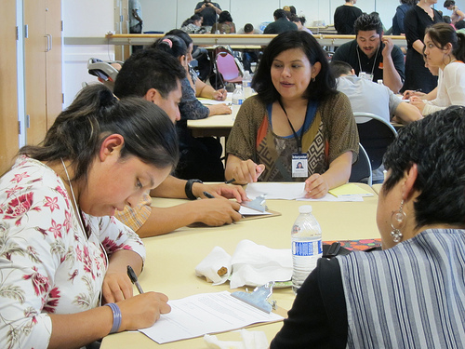Considering the prevalence of electronic methods suggested for communicating with the City in the previous questions, it was surprising that electronic methods were mentioned less often than print (34%), including newsletters or other mail sent to their homes, or distributed via brochures or flyers; community meetings, like the focus group they were participating in (29%); and media (29%), including TV news or ads (23%), radio (11%), and newspaper (3%). All electronic methods together (email, website, and "Internet") were mentioned by 22%. Nine percent suggested providing resources to community agencies to continue their work. It may be that participants prefer a print version of information that would be used to participate in improving their community, but an electronic version of other types of information, such as City, government, and community news.

**Learning**

**Learning**

* Learning computer skills... Be a savvier Internet users - to use it in a faster way
* I would like to learn how to use Internet and computers.
* How to use them to share relevant information.
* How to safely use a computer and how to limit the access to porn sites
* How to connect with more groups and networks and how to make money out of it.
* Knowing who manages the information we put into the computer.
* Programs, software, how to navigate, how to download educational programs.
* Don't know how to use computers, but I hope can have a workshop.
* Of course I would like to, but because of my economic situation, I cannot.

In *mutual interviewing*, 80% identified computer- and Internet-related topics they'd like to learn more about, including the basics of computer and Internet use (46%), intermediate computer and Internet skills (23%), and more about privacy related to the Internet (11%).

Participants were diverse in their preferred learning environments with about half each selecting classes (52%) and short workshops (45%). Not quite as many selected individual training (39%) and only 13% selected videos.

|  |  |
| --- | --- |
|  | See the full report with other focus groups and survey results at Seattle.gov/tech/indicators   Produced by the City of Seattle Department of Information Technology  Community Technology Program |

|  |  |
| --- | --- |
|  | See the full report with other focus groups and survey results at Seattle.gov/tech/indicators   Produced by the City of Seattle Department of Information Technology  Community Technology Program |

|  |  |
| --- | --- |
|  | See the full report with other focus groups and survey results at Seattle.gov/tech/indicators   Produced by the City of Seattle Department of Information Technology  Community Technology Program |

|  |  |
| --- | --- |
|  | See the full report with other focus groups and survey results at Seattle.gov/tech/indicators   Produced by the City of Seattle Department of Information Technology  Community Technology Program |

|  |  |
| --- | --- |
|  | See the full report with other focus groups and survey results at Seattle.gov/tech/indicators   City of Seattle Department of Information Technology  Community Technology Program |